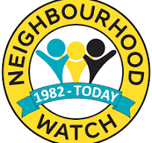

Always leave your bins somewhere safe and out of reach of the public. Bins can be used as a climbing aid to gain entry to your home via opened upstairs window or into your garden, using your bin to climb over a gate where they are less likely to be seen.

To prevent this from happening, try putting your bins behind a locked gate or in a bin store so that only you can get access to them and ensure your windows are closed and locked when you are not in your property

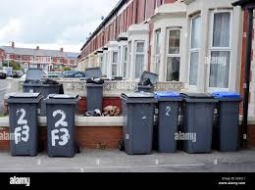#itnevercrossedmymind #humberwatch